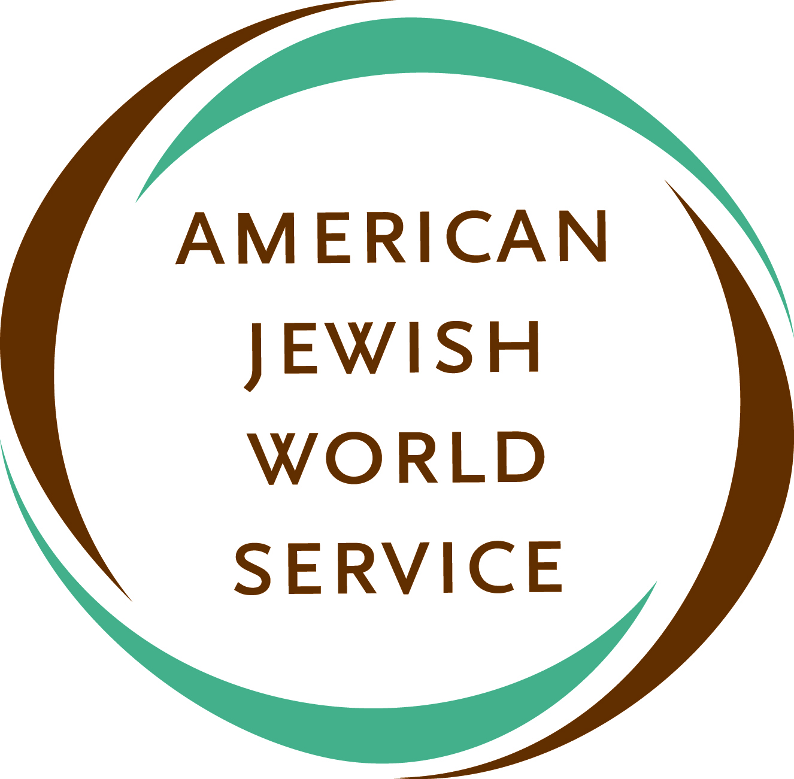
Contact:
Rebecca Kaplan
212.792.2889
rkaplan@ajws.org

45 West 36th Street  New York, NY 10018  212.792.2900  www.ajws.org
____________________________________________________________________________________

PRESS RELEASE

AMERICAN JEWISH WORLD SERVICE ANNOUNCES FIRST ROUND OF GRANTS TO AID THE PHILIPPINES
Three Filipino grassroots organizations to receive disaster aid

NEW YORK, NY —American Jewish World Service (AJWS), the leading Jewish international human rights and development organization, announced today that it selected three Filipino grassroots organizations to receive the first round of disaster relief grants in the wake of Typhoon Haiyan (Yolanda). AJWS has raised almost $500,000 since the typhoon first hit the Philippines. The three grantees are Center for Empowerment and Resource Development (CERD), Center for Trade Union and Human Rights (CTUHR) and National Union of People’s Lawyers (NUPL).

“AJWS provides support to organizations which are rooted in the communities that are most affected by disasters and that will continue to respond to their needs after many international relief organizations have come and gone,” said Shari Turitz, vice president of international programs of AJWS. “As we have done in the wake of other disasters, we identified community-based organizations in the Philippines to use this emergency funding effectively where it is most urgently needed.”

“The three Filipino organizations we are supporting have been in the country for years and are already on-the-ground providing critical services to the typhoon survivors, including distributing food and supplies, importing water and sanitation equipment and providing medical treatment,” said Ruth Messinger, president of AJWS. “These grants are crucial to the local recovery process. We stand with the survivors of the typhoon and will make additional grants to organizations working in the Philippines in the coming days and weeks.”

To start its grant making in the Philippines, AJWS is providing $70,000 to CERD, CTUHR and NUPL combined. AJWS is also granting $45,000 to Médecins Sans Frontières (MSF) to support its critical medical response in the aftermath of the typhoon. When supporting an international group is the most effective route, AJWS funds those organizations.

With more than 27 years of experience working with community-based organizations in Asia, Africa, Latin America and the Caribbean, AJWS has responded to numerous natural and man-made disasters, including the 2011 famine in East Africa, the 2010 earthquake in Haiti and the 2004 tsunami in Southeast Asia.

Below is additional information on CERD, CTUHR, NUPL and MSF.

Center for Empowerment and Resource Development (CERD)
CERD, based in Quezon City, Philippines, was founded in 1979 as a human rights organization addressing the needs of fisherfolk to effectively manage the marine and coastal resources on which they depend for livelihood. Immediately after Typhoon Haiyan subsided, CERD Staff in Northern Samar conducted a Damage and Needs Assessment (DANA) in eight coastal villages of Biri and eight coastal villages of Mondragon, Northern Samar and have started food distribution to families in Mondragon.

Center for Trade Union and Human Rights (CTUHR)
CTUHR, based in Quezon City, Philippines, is a human rights organization engaged in documentation and monitoring of human rights violations committed against workers around the country. CTUHR conducts research and supports advocacy campaigns for workers' rights promotion and protection. CTUHR has an extensive network of partners throughout the country and specifically in some of the hardest hit areas in Southern Leyte and Cebu. CTUHR is coordinating with local organizations to collect money and in-kind donations for survivors of the Typhoon who are not being reached by national relief efforts. Specifically, CTUHR colleagues in Southern Leyte are setting up drop off centers for relief goods in Ormoc City. Priority areas are Leyte towns of McArthur, Gulan, Hernani, Magdulong, Salcedo, Isabel, Guinapundan, Balangiga and Basey, Western Samar.

National Union of People’s Lawyers (NUPL)
NUPL, based in Quezon City, Philippines, is a nationwide voluntary association of human rights lawyers and has 19 chapters around the country, including in the Eastern Visayas, the epicenter of the Typhoon. As part of its initial response, NUPL has started to collect donations and bring food and water to affected areas as supplies are running low. Included among the supplies it is providing are relief packs consisting of ready to eat meals, clothing, blankets, tarpaulins, simple shelter materials and rice. It is also sending its local human rights defender members to coordinate the transport and distribution of items and to assess further needs.

Médecins Sans Frontières (MSF)
MSF is an international, independent, medical humanitarian organization that delivers emergency aid to people affected by armed conflict, epidemics, natural disasters and exclusion from healthcare. MSF offers assistance to people based on need, irrespective of race, religion, gender or political affiliation. MSF is rapidly scaling up its response to Typhoon Haiyan and will have more than 100 staff in the area in the coming days, including doctors, nurses, surgeons, logisticians, psychologists and water and sanitation experts. Nine planeloads of aid materials—including medical supplies, shelter materials, hygiene kits, and water and sanitation equipment—are being dispatched to the Philippines from MSF warehouses around the world. Three of the planes arrived in Cebu on November 13.

###

American Jewish World Service
Inspired by the Jewish commitment to justice, American Jewish World service (AJWS) works to realize human rights and end poverty in the developing world. www.ajws.org

